CHAPTER 23
ELECTRIC POTENTIAL
Discussion Questions
Q23.1 The concept of potential is useful for the same reason that electric field is useful. It allows us to calculate the effect of the source charges on the space surrounding them. A test charge then has electrical potential energy when placed in the potential of the source charges. And electric potential will prove to be a very useful concept for analyzing electrical circuits.

Q23.2 Yes, just bring the test charge in along the perpendicular bisector of the line that connects the two charges. The electric potential is zero at all points along this line, since all points on the line are equidistant from the two charges. There is no change in potential along the line so no work is done on the test charge anywhere along the line. The two charges produce a net electric field along this line, but at all points on the line the electric field has no component parallel to the line. So the electric force does no work on a test charge moving along this line.

Q23.3 If the potential where the two charges are infinitely far apart is taken to be zero, then the electric potential energy of the pair is 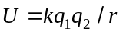. Only for is this zero, so it is not possible for two charges. For three charges not all of the same sign it is possible. You need just to arrange the separations of the three charges 1, 2, and 3 such that 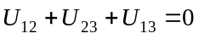.

Q23.4 The voltmeter reads the potential difference between the two points to which it is connected. The potential difference between two points is independent of the choice for the reference level of zero potential.

Q23.5 If 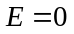 along the path then the work done by the electric force on a test charge as it moves along this path is zero. Eq.(23.13) then says that 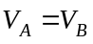. 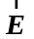 does not have to be zero everywhere along other paths connecting and , but the work done by on a test charge must be zero along any of these paths. This is because the electric force is a conservative force and the work it does is path independent.

Q23.6 Eq.(23.17) says that is constant throughout this region but it isn’t necessarily zero.

Q23.7 Electric field lines point away from positive charge and toward negative charge. Potential is large and positive near positive charge and low (large in magnitude and negative) near negative charge. Therefore, electric fields are always in the direction of lower potential; electric-field lines point from high to low potential. For another way to show this, consider a positive test charge that moves from point to point . 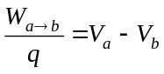, where 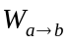 is the work done on charge by the electric field in which it moves. If the electric field is in the direction from to , then the direction of the force on is from to and this force does positive work. 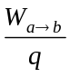 then is positive and 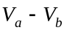 is positive. Therefore, 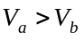 and the electric field direction is the direction of decreasing potential.

Q23.8 (a) No. At a point midway between two point charges of equal magnitude and opposite sign the potential (relative to infinity) is zero but the electric field is not zero. The electric field is directed toward the negative charge. (b) No. At a point midway between two equal point charges (equal in magnitude and sign) the electric field is zero and the potential (relative to infinity) is not zero. The potential depends on the electric field along a path from infinity to the point, not just on the electric field at the point.

Q23.9 The electric force is conservative so the work it does is path independent and is zero for any closed path. By Eq.(23.17) the integral 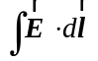 from point to point equals 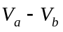. But when and are the same point the potential difference is necessarily zero so the integral completely around a closed path must be zero.

Q23.10 If they are placed negative terminal to positive terminal, the potential increases by 3.0 V in going from the negative terminal of the first to the positive terminal of the second. If they are placed positive terminal to positive terminal, the potential rises 1.5 V across one battery and decreases 1.5 V across the second one so the potential difference between the terminals of the exposed ends is zero.

Q23.11 The static charge on your body is at very high potential but the amount of net charge is very small so the potential energy of that charge is small. The power line is capable of delivering a much larger amount of electrical energy because much more charge flows from it.

Q23.12 Eq.(23.20) shows that is determined by the change with distance of 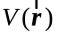. at a single point tells us nothing about .

Q23.13 There is no ambiguity because at this point and therefore has no direction.

Q23.14 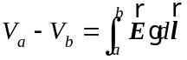. If the direction from a to b is the same as the direction of , then the integral is positive and . Therefore, the electric field always points toward lower potential. In a direction perpendicular to the electric field the potential is constant since in that case and 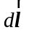 are perpendicular and 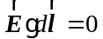. Therefore 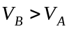, 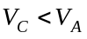 and 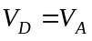

Q23.15 No. At a point one meter from an isolated positive point charge the electric potential is positive but there is no charge at this point. At a point one meter from an isolated negative point charge the electric potential is negative but there is no charge at this point. For both these examples we are taking 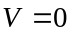 at an infinite distance from the point charge. The choice of zero potential determines whether a particular point has positive or negative potential, and this choice is arbitrary.

Q23.16 Consider charge 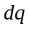 added to the sphere after it already has charge . The potential of the surface of the sphere at this point in the charging process is 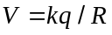, where is the radius of the sphere. The potential energy of when it is placed on the sphere is then 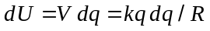. The total potential energy of the charged sphere is
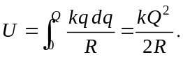

Q23.17 It doesn’t matter. Any convenient choice can be made for what equipotential we call 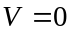.

Q23.18 The electric field inside the sphere is zero, no matter where the sphere is placed and no matter whether the sphere has a net charge or not. In electrostatics, the electric field within a conductor is always zero. All points of the sphere are at the same potential, but the value of this potential depends on how far the sphere is from the positively charged plate. This is true whether the sphere has net charge or not.

Q23.19 The electric field is zero in the conductor and in the cavity, so the potential is constant in these regions. The potential in the cavity equals the potential in the material of the conductor.

Q23.20 The body of the car and its interior are both at the same potential so people inside the car are unaffected. The potential difference between the car and the ground is 10,000 V so when a person steps out this potential difference appears between their foot on the ground and the part of them still in contact with the car and a very dangerous current flows through them.

Q23.21 The static electricity in the atmosphere can place a net charge on the ship. The light appears when this charge discharges into the air. The electric field 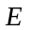 is largest near sharp points so this is where the discharge occurs. The seawater on the wet masts conducts the charge to the discharge point.

Q23.22 This is true and is an example of the “image charge” method often used in solving certain electrostatic problems. In Fig.23.23b, the electric field lines are symmetric about the line that runs between them and would be perpendicular to a plane running along this line and consisting of points equidistant from the two charges. The electric field is perpendicular to a conducting surface so the field lines in half the figure would be unchanged by replacing one of the charges by a conducting surface at this plane.

